IBM ASSIGNMENT 1

Name: Maheshwari. A

Reg no:212919205023

Many times we need to monitor the person/people visiting some place like Seminar hall, conference room or Shopping mall or temple. This project can be used to count and display the number of visitors entering inside any conference room or seminar hall. Visitor counting is simply a measurement of the visitor traffic entering and exiting conference rooms, malls, sports venues, etc. With the increase in standard of living, there is a sense of urgency for developing circuits that would ease the complexity of life. Over the years, the usage of Visitor counters has become very positive in terms of monitoring crowd behavior at a particular place. Now, due to technology advancement, various type of people counter has been introduced to automatically count the number of people entering and exiting a building at a particular time. Some of these are laser beam, thermal imaging, video camera and the infra-red sensor. All these sensors play their role respectively as visitor detector. These devices are very reliable and accurate in terms of performance as compared to the mechanical tally counter. This system is helpful for counting the number of people in an auditorium or halls for seminar to avoid congestion. Moreover it can also be used to check the number of people who have come to an event or a museum to watch a certain exhibit. This project presents the design and construction of a digital bidirectional visitor counter (DBVC). The DBVC is a reliable circuit that takes over the task of counting number of persons / visitors in the room very accurately.

Circuit Layout:

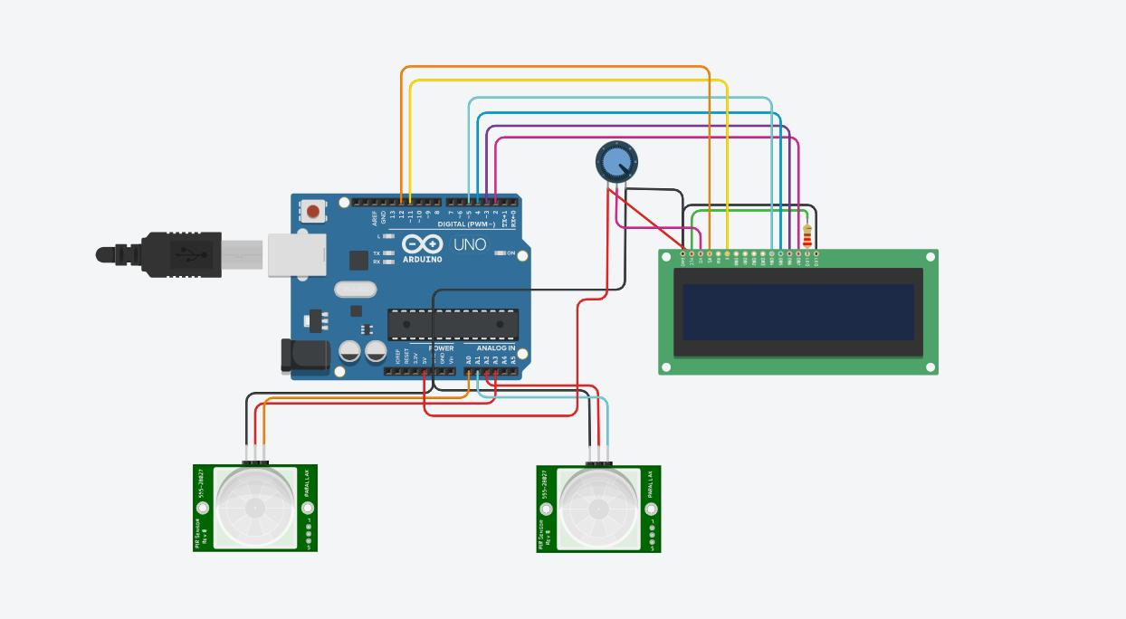

Code:in

#include <LiquidCrystal.h>

Int in = 15;

Int inpr = 16;

Int out = 14;

Int outpr = 17;

Int ppl = 0;

LiquidCrystal lcd(12, 11, 5, 4, 3, 2);

Bool pi = 0;

Bool po = 0;

Void setup() {

pinMode(15, INPUT);

pinMode(14, INPUT);

pinMode(16, OUTPUT);

pinMode(17, OUTPUT);

lcd.begin(16, 2);

}

Void loop() {

Lcd.clear();

digitalWrite(outpr, HIGH);

digitalWrite(inpr, HIGH);

pi = digitalRead( in );

po = digitalRead(out);

if (pi == 1) {

ppl--;

delay(500);

} else if (po == 1) {

Ppl++;

Delay(500);

}

Ppl = constrain(ppl, 0, 50);

Lcd.setCursor(0, 0);

Lcd.print(“PEOPLE IN:”);

Lcd.setCursor(11, 0);

Lcd.print(ppl);

If (ppl >= 20) {

Lcd.setCursor(0, 1);

Lcd.print(“PLEASE WAIT”);

Delay(1000);

}

If (ppl <= 19) {

Lcd.setCursor(0, 1);

Lcd.print(“PLEASE VISIT”);

Delay(1000);

}

}

Output:

